­­­­­

|  |  |
| --- | --- |
|  |  |



Process Definition

Document

Loan Application Automation - PDD

This document describes a process for automating the Loan Application Processing at UiBank. This involves automating various tasks related to personal loan applications, including handling emails, reading CSV files, entering loan data into a banking application, generating Loan IDs, and sending responses back to the business. The automation is proposed using UiPath Robotic Process Automation (RPA) to streamline and reduce manual intervention.

Table of Contents

I. INTRODUCTION 5

1.1 Purpose 5

1.2 Objectives 5

1.3 Key Contacts 5

1.4 Minimum Pre-requisites for the Automation 6

II. AS IS Process description 6

2.1 Process Overview 6

2.2 Applications Used 7

2.3 AS IS Process Map 8

2.3.1 High Level Process Map 8

2.3.2 Detailed Level Process Map 8

2.4 Process Statistics 9

2.5 Detailed As Is Process Actions 10

III. TO BE Process description 15

3.1. Detailed TO BE Process Map 15

3.2. Parallel Initiatives 15

3.3. In Scope For RPA 16

3.4. Out Of Scope for RPA 16

3.5. Exceptions Handling 16

3.5.1. Known Business Exceptions 16

3.5.2 Unknown Business Exceptions 17

3.6. Applications Errors & Exceptions Handling 17

3.6.1. Known Applications Errors and Exceptions 17

3.6.2. Unknown Applications Errors and Exceptions 18

3.7. Reporting 18

IV. Other 19

4.1. Additional sources of process documentation 19

# INTRODUCTION



## Purpose

The Process Definition Document outlines the business process chosen for automation. The document describes the sequence of actions performed as part of the business process, the conditions and rules of the process prior to automation (**AS IS**) as well as the new sequence of actions that the process will follow as a result of preparation for automation (**TO BE**).

**The PDD is a communication document between:**

* The RPA Business Analyst and the SME/Process Owner. The goal is to ensure that the RPA Business Analyst has the correct understanding of the process and has represented it accurately.
* The RPA Business Analyst and the Development team (represented by the Solution Architect and RPA Development Lead). The goal is to ensure that the process is documented appropriately and to a sufficient level of detail so that the Solution Architect can then create the solution based on the PDD content.

## Objectives

The business objectives and benefits expected by the Business Process Owner after automation of the selected business process are:

* Reduce processing time per item by 80%.
* Better Monitoring of the overall activity by using the logs provided by the robots.

## Key Contacts

Add here any stakeholders that need to be informed or to approve changes to the process:

|  |  |  |  |
| --- | --- | --- | --- |
| Role | Name | Contact Details (email, phone number) | Notes |
| Process Owner | Wan Chee Tin | kwct.1997@outlook.com |  |
|  |  |  |  |

## Minimum Pre-requisites for the Automation

1. Filled in Process Definition Document
2. Test Data to support development
3. User access and user accounts creations (licenses, permissions, restrictions to create accounts for robots)
4. Credentials (user ID and password) required to logon to machines and applications

# AS IS Process description

In this section the Business Analyst will document the process. This section will serve as the starting point for the re-engineering and automation effort.



## Process Overview

Section contains general information about the process before automation.

|  |  |
| --- | --- |
| Item | Description/Answer |
| Process Full Name | Loan Application Automation |
| Process Area | Banking |
| Department | Loan |
| Short Description (operation, activity, outcome) | This document describes a process for automating the Loan Application Processing at UiBank. This involves automating various tasks related to personal loan applications, including handling emails, reading CSV files, entering loan data into a banking application, generating Loan IDs, and sending responses back to the business. The automation is proposed using UiPath Robotic Process Automation (RPA) to streamline and reduce manual intervention. |
| Role(s) required in applications to perform the process | Loan Officer |
| Process schedule and frequency | Weekly |
| Number of times the process is ran by selected frequency | 100 – 300 |
| Process execution time | 15 mins per transaction |
| Process Restrictions | N/A |
| Peak Period (s) | Last working day of the month |
| Peak Volume Approximate increase | 250+ |
| Number of persons performing the process | 3 |
| Expected Volume increase during next periods | N/A |
| Percentage Un-handled exceptions | N/A |
| Input data description | Email, CSV file |
| Output Data description | CSV file, Summary Email |

*Add more rows to the table to include relevant data for the automation process. No fields should be left empty. Use “n/a” for the items that don`t apply to the selected business process.

## Applications Used

The table includes a comprehensive list of all the applications that are used as part of the process to be automated to perform the given actions in the flow.

|  |  |  |  |  |  |
| --- | --- | --- | --- | --- | --- |
| Application Name | Version | Application Language | Thin/Thick Client | Environment/ Access method | Comments |
| Google Chrome | Version 136.0.7103.48 (Official Build) (64-bit) | English | Thin | Read, Write |  |
| MS Excel 2019 | Version 2503 Build 16.0.18623.20208 (32-bit) | English | Thick | Read, Write |  |

*Add more rows to the table to include the complete list of applications.

## AS IS Process Map

This section contains various process maps contributing to a better understanding of how the process is performed pre-automation.

### High Level Process Map

This section is useful for the Business Analyst in presentations and discussions with management to underline areas of weakness, inefficiency or to demonstrate which actions could be in scope for automation.

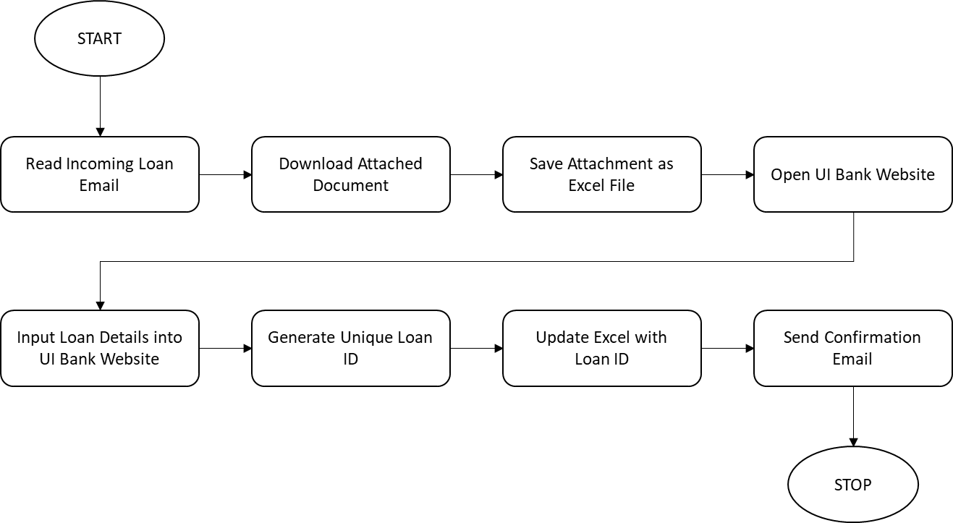

### Detailed Level Process Map

This section describes the process at key-stroke level and is an essential part for the communication with the developers.

* **Start Process**  
  Action: The process begins.
* **Read Incoming Loan Email**  
  Action: The system or user reads the email containing the loan details.
* **Download Attached Document**  
  Action: The attachment from the email, which likely contains loan information, is downloaded.
* **Save Attachment as Excel File**  
  Action: The downloaded attachment is saved as an Excel file to a designated location.
* **Open UI Bank Website**  
  Action: The UI Bank website is opened to enter the loan data.
* **Input Loan Details into UI Bank Website**  
  Action: The loan details from the email or attachment are entered into the UI Bank website.
* **Generate Unique Loan ID**  
  Action: The system generates a unique Loan ID once the loan details have been entered.
* **Update Excel with Loan ID**  
  Action: The generated Loan ID is recorded in the previously saved Excel file containing the loan details.
* **Send Confirmation Email**  
  Action: A confirmation email is sent to notify the relevant party (e.g., loan applicant or internal team) about the loan process.
* **Stop Process**  
  Action: The process concludes after the confirmation email has been sent.

## Process Statistics

**High Level statistics – 1 Transaction**

|  |  |  |  |  |  |  |  |
| --- | --- | --- | --- | --- | --- | --- | --- |
| Processes | Windows | Actions | Mouse clicks | Keys pressed | Text entries | Hotkeys used | Time |
| 3 | 5 | 48 | 30 | 0 | 0 | 11 | 15 mins. |

**Detailed statistics**

|  |  |  |  |
| --- | --- | --- | --- |
| Window name | Mouse clicks | Text entries | Key pressed |
| Mail - Kris Wan - Outlook - Personal - Microsoft​ Edge | 2 | 0 | 0 |
| Downloads - File Explorer | 1 | 0 | 0 |
| LoanData.csv - Excel | 14 | 0 | 0 |
| UiBank-Loan Apply - Google Chrome | 12 | 0 | 0 |
| UiBank-Loan result - Google Chrome | 1 | 0 | 0 |

## Detailed As Is Process Actions

|  |  |
| --- | --- |
| 1. Download attachment from email. | |
|  |  |

|  |  |
| --- | --- |
|  |  |
|  | Est. time: 1.5 sec. |
| image | Action: Click |

|  |  |
| --- | --- |
|  |  |
|  | Est. time: 1.5 sec. |
| image | Action: Click |

|  |  |
| --- | --- |
| 1. Process downloaded attachment and apply loan application on UiBank website. | |
|  |  |

|  |  |
| --- | --- |
|  |  |
|  | Est. time: 1.7 sec. |
| image | Action: Double Click |

|  |  |
| --- | --- |
| * 1. Press 'Ctrl+c' |  |
|  | Est. time: 0.3 sec. |
| image | Action: Hotkey |

|  |  |
| --- | --- |
|  |  |
|  | Est. time: 1.8 sec. |
| image | Action: Click |

|  |  |
| --- | --- |
| * 1. Press 'Ctrl+c' |  |
|  | Est. time: 0.2 sec. |
| image | Action: Hotkey |

|  |  |
| --- | --- |
|  |  |
|  | Est. time: 1.3 sec. |
| image | Action: Click |

# TO BE Process description

In this section the proposed improvements to the process, actions to the process will be outlined as well as the actions proposed for automation and the type of robot required. **This will be cross-checked by the Solution Architect.**

## Detailed TO BE Process Map

A detailed process map of the process as it will look like post-automation will be outlined here.  
  
*Highlight Bot interventions/ To-Be automated actions with different legend/ icon (purple).  
Mention below if process improvements were performed on the To-Be design and provide details.*

|  |  |
| --- | --- |
| Legend | Description |
|  | Action number in the process. Referred to in details or Exceptions and Errors table. |
|  | This process action is proposed for automation. |
|  | This process action remains manual (to be performed by a human agent). |

## Parallel Initiatives

The table below will capture the proposed Business, Process or Application changes to be made in the near future that would impact the process at hand (if any).

|  |  |  |  |  |
| --- | --- | --- | --- | --- |
| Initiative Name | Process Action(s) where it is identified | Impact on current Automation Request | Expected Completion Date | Contact Person |
| N/A | N/A | N/A | N/A | N/A |

## In Scope For RPA

The actions in scope for RPA should be listed below:

1. Receive the email sent from the business team.
2. Download the email attachment containing loan application details.
3. Read the CSV/Excel file.
4. Open the UI Bank website and input the loan data.
5. Generate the loan ID.
6. Return the loan ID and send confirmation email to the business team.

## Out Of Scope for RPA

The actions **out of scope** for RPA should be listed in the table below together with the reasoning.

|  |  |  |  |
| --- | --- | --- | --- |
| Activity/Action* | Reason for out of scope | Impact on the TO BE | Possible measures to be taken into consideration for future automation |
| Action 1 | RPA is limited to processing CSV files. Non-CSV formats (e.g., PDF, Word) are not supported. | User must manually process the data and convert it to CSV, causing a delay in the process. | Future automation should include a tool to automatically detect and convert various formats to CSV. |

*Add more rows to the table to reflect the complete documentation provided to support the RPA process.

## Exceptions Handling

The Business Process Owner and Business Analysts are expected to document below all the business exceptions identified in the automation process. Exceptions are of 2 types and both need to be addressed:

**Known exceptions** = previously encountered. A scenario is defined with clear actions and workarounds for each case.

**Unknown** = New situation that was not encountered before. It cannot be predicted and in case it happens it needs to be flagged and communicated to an authorized person for evaluation.

### Known Business Exceptions

Details regarding how the robot should handle the exceptions.

|  |  |  |  |
| --- | --- | --- | --- |
| Exception Name | Action | Parameters | Action to be taken |
| Email not received. | Check email client | Email server error. | Retry the process. If still not received, log the error and send an alert to the admin. |
| Attachment missing or corrupted. | Download the attachment. | File download error. | Retry to download the file. If unsuccessful, notify the user for manual intervention. |

### 3.5.2 Unknown Business Exceptions

An umbrella rule that includes a notification needs to be designed for all other exceptions that could happen and cannot be anticipated.

***e.g.:*** *for all other cases which do not follow the rules defined an e-mail should be sent to:* [*exceptions@company.com*](mailto:exceptions@company.com) *with a screen shot and robot should proceed to next transaction.*

## Applications Errors & Exceptions Handling

A comprehensive list of all errors, warnings or notifications should be consolidated here together with the action to be taken for each by the Robot. There are 2 types of exceptions/errors:

**Known** = Previously encountered and action plan or workaround available for it (e.g. SAP unresponsive during peak times)

**Unknown** = these are exceptions and errors that cannot be anticipated but for which the robot needs to have a rule so that the RPA solution is sustainable.

### Known Applications Errors and Exceptions

Details regarding how the robot should handle the exceptions.

|  |  |  |  |
| --- | --- | --- | --- |
| Error/Exception Name | Action | Parameters | Action to be taken |
| File format not supported. | Open file. | File format error. | Notify the user to provide the file in the required format (CSV). |
| UI Bank website not responding. | Open UI Bank website. | Application error. | Attempt to restart the UI Bank application. If the issue persists, notify the admin. |
| Completion email not sent. | Send confirmation email. | Email sending error. | Retry sending the email. If failed, alert the admin or retry manually. |
| MS Office not installed. | Install MS Office. | MS Office installation error. | Notify the user or admin to install MS Office to proceed with the file operations. |
| Browser extension missing. | Check browser extension. | Extension missing error. | Notify the user to install the necessary browser extension or contact the admin for installation. |

### Unknown Applications Errors and Exceptions

An umbrella rule that includes a notification needs to be designed for all other exceptions that could happen and cannot be anticipated.

*e.g. robot should attempt to access the application 3 times then it should terminate thread.*

## Reporting

In this section all the reporting requirements of the business should be detailed so that when the RPA solution is moved to production the administrators can track the performance of the solution.

|  |  |  |  |
| --- | --- | --- | --- |
| Report Type | Update frequency | Details | Monitoring Tool to visualize the data |
| N/A | N/A | N/A | N/A |

* For complex reporting requirements, include them into a separate document and attach it to the present documentation

# Other

## Additional sources of process documentation

If there is additional material created to support the process automation please mention it here, along with the supported documentation provided.

|  |  |  |
| --- | --- | --- |
| Additional Process Documentation | | |
| Video Recording of the process (Optional) | **N/A** | **N/A** |
| Business Rules Library (Optional) | **N/A** | **N/A** |
| Other documentation (Optional) | **N/A** | **N/A** |
| Standard Operating Procedure(s) (Optional) | **N/A** | **N/A** |
| High Level Process Map (Optional) | **N/A** | **N/A** |
| Detailed level process map (Optional) | **N/A** | **N/A** |
| Work Instructions (Optional) | **N/A** | **N/A** |
| Input Files (Optional) | **N/A** | **N/A** |
| Output Files (Optional) | **N/A** | **N/A** |

*Add more rows to the table to reflect the complete documentation provided to support the RPA process.

